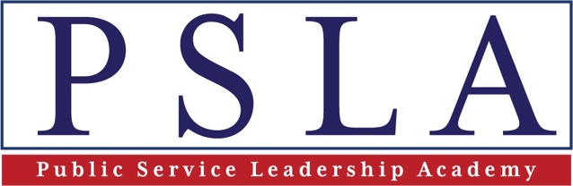

Leadership Development Program Application

Applicant Information
Full Name: |  |  |  | Date:
 | Last | First | M.I.

Job Title :
Functional Area:

Agency/Department:

Office:

Work Phone: |  | Cell Phone:

Work Email: |  | Personal  Email:

Work Address: |  | Home  Address:

References
Please list supervisor information.
Full Name: |  | Job Title:
Email Address: |  | Phone:
Address:

Professional Experience
Total Years at the Agency: |  | Total Years in the Government:
GS Level of Equivalent:

Supervisory Experience: People, Projects, Initiatives (300 words)

Describe current job responsibilities: (300 words)

Describe your short- and long-term career objective(s). Why is leadership development important at this point of your career? (300 words)

List the name, date attended and provider of any other leadership, management or other programs you have participated in over the last five years. (300 words)

What are you looking for in a leadership development program?

Are you interested in applying for the Senior Executive Service?

How did you learn about this program?

Did you go through the internal review and approval process?

Other

Gender: |  | Race/Ethnicity :

Please attach both resume and a letter of recommendation from supervisor or reference (including name & title).

Please email application, letter of recommendation and resume to MarthaDorrisPSLA@gmail.com!

